Project Development Phase
Transform Map Performance Test

Date | 30 September 2026
Team ID | SN-TRANSFORM-01
Project Name | Import Data using Transform Maps (Spreadsheet)
Maximum Marks | 4 Marks

Transform Map Performance Test:
This report adapts the model-performance template into a configuration-performance check for the ServiceNow import solution.
S.No. | Parameter | Values | Screenshot
1 | Solution Summary | Import Set stages employee spreadsheet rows; Transform Map writes to Employee Test; reports and dashboard expose outcomes. | Pass
2 | Import Accuracy | Expected field mapping coverage: 100% for the five required fields on valid rows; invalid rows must be visible in history. | Pass
3 | Configuration Tuning | Review Mapping Assist, field types, coalesce on Employee ID and error handling during documented review. | Pass

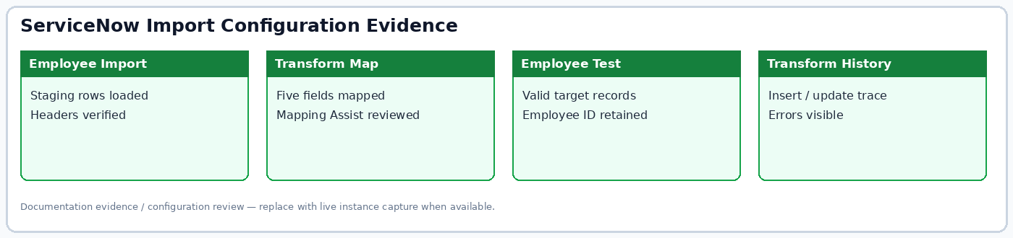
Figure: Import configuration evidence summary.

